****

**JIBLink User Manual**

Basic Service Partner (BSP)

Last Updated August 2012 (Release 3.4)

**TABLE OF CONTENTS**

[1 How Do I Access JIBLink? 1](#_Toc333838472)

[1.1 How Do I Login Directly to the JIBLink Website? 1](#_Toc333838473)

[1.2 Email Notifications 2](#_Toc333838474)

[1.2.1 Viewing an Invoice/Statement via Email Notification 3](#_Toc333838475)

[1.2.2 Viewing Attachments via Email Notification 4](#_Toc333838476)

[1.2.3 Printing an Invoice/Statement via Email Notification 5](#_Toc333838477)

[2 Managing your Invoices/Statements using JIBLink 6](#_Toc333838478)

[2.1 Navigating the JIBLink “Inbound – Invoice Search” screen 6](#_Toc333838479)

[2.1.1 Search Fields 6](#_Toc333838480)

[2.1.2 Page Numbers for Multiple Records 7](#_Toc333838481)

[2.1.3 Sorting Invoices/Statements 8](#_Toc333838482)

[2.1.4 Invoice Status Column 8](#_Toc333838483)

[2.2 Cancelling; and Removing the Cancel Status on an Invoice/Statement 9](#_Toc333838484)

[2.3 How to Contact Your Operator 10](#_Toc333838485)

[2.4 Print Sections of an Operator Invoice/Statement 10](#_Toc333838486)

[2.5 Invoice and Property Comments 12](#_Toc333838487)

[2.5.1 Viewing Invoice Comments 12](#_Toc333838488)

[2.5.2 Viewing Property Comments and Attachment(s) 13](#_Toc333838489)

[3 Updating Company & User Information 14](#_Toc333838490)

[3.1 Updating Company Address and Contacts 14](#_Toc333838491)

[3.2 Updating your User Information and Password 15](#_Toc333838492)

# How Do I Access JIBLink?

As a designated BSP (Basic Service Partner) you are authorized and set-up to access and use the JIBLink website. You would have received notice to this status in the form of a letter. In that letter, you would have been assigned a User ID and a temporary Password to activate your JIBLink account.

Once your account is activated, you will be registered with JIBLink. Once registered, there are two ways you can access the website to view or print JIBs and other statements generated by an Operator:

1. *Use* a web browser to godirectly to [www.jiblink.com](http://www.jiblink.com); or
2. *Click on* a hyperlink embedded in an email notification you receive when an Operator sends a new invoice/statement

In either case, the JIBLink Login page will be displayed with prompts for you to enter your User ID and Password.

JIBLink Login page

**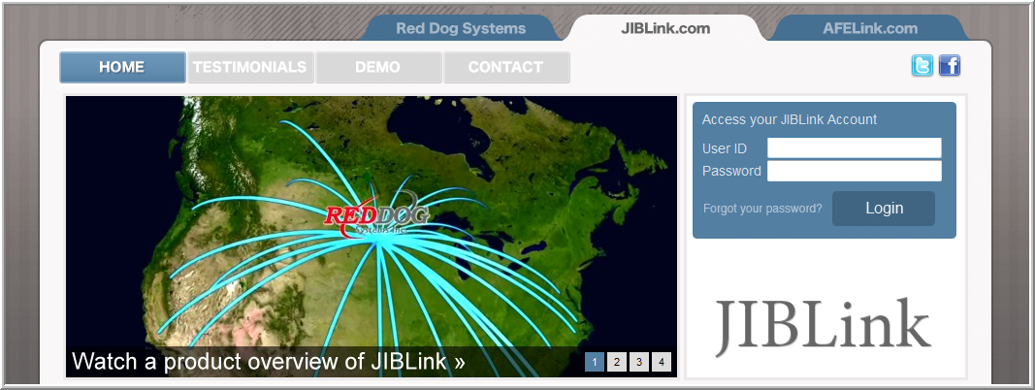**

## How Do I Login Directly to the JIBLink Website?

*Launch your web browser* and type in the JIBLink website address [www.JIBLink.com](http://www.JIBLink.com). Once the JIBLink Login page is displayed on your screen, simply *type* *in* your User ID and Password in the boxes and *click the* “Login” *button*.



(2) *Click* on the “Login” button.

(1) Type in your User ID and Password in boxes.

Once you have successfully logged in, a screen called “Inbound-Invoice Search” will be displayed.

Example ‘Inbound-Invoice’ screen

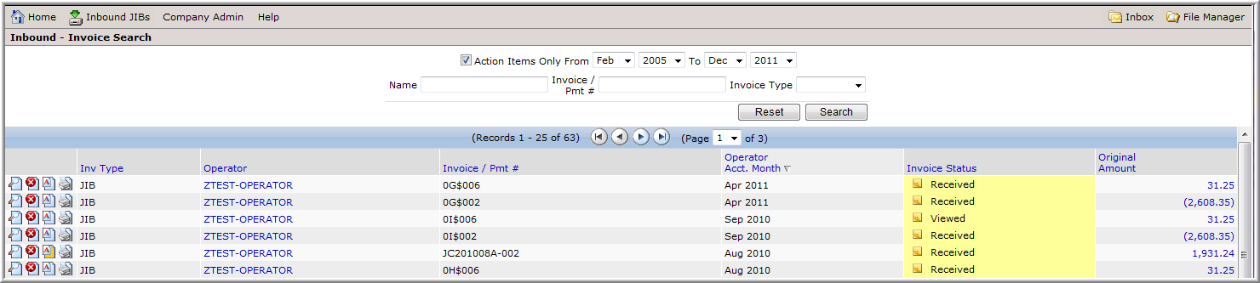

## Email Notifications

When an Operator releases their invoices/statements, Partners/Owners will receive an email notification stating there is a “New JIBLink General Notification”.

The email notification will be coming from: [messenger@reddogsystems.com](mailto:messenger@reddogsystems.com)

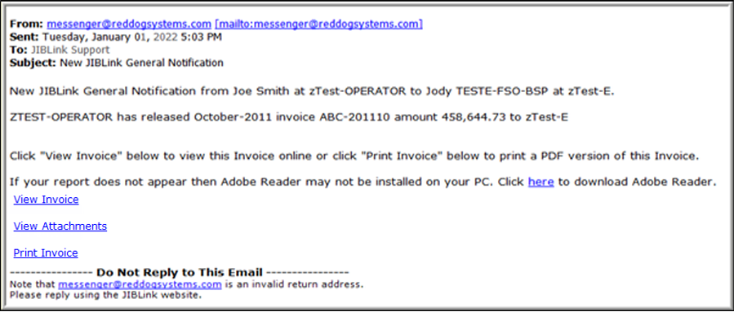

Hyperlinks to *click on*,

see section 1.2.1, 1.2.2 and 1.2.3

The email notification has instructions for the available options regarding the invoice/statement that was released by the Operator. There are active hyperlinks embedded within the email that you can *click on* to either “View Invoice”, “View Attachments” or “Print Invoice”.

**Note**: “View Attachments” only appears if there are supplementary attachments (such as excel spreadsheets) from the Operator.

### Viewing an Invoice/Statement via Email Notification

*Click on* *the hyperlink text* “View Invoice” in the email, as in the example above, to view the invoice/statement on the screen. Clicking on “View Invoice” will launch the JIBLink website. Once the JIBLink Login page is displayed on your screen, simply *type in* your Password in the box (the User ID for your account will appear automatically in the User ID box as it is pre-populated) and *click on* the “Login” button.



(1) *Type in* your Password in box.

(2) *Click* on the “Login” button.

Once you have successfully logged in, a screen called “Invoice - Inbound” will be displayed.

Example ‘Invoice - Inbound’ screen

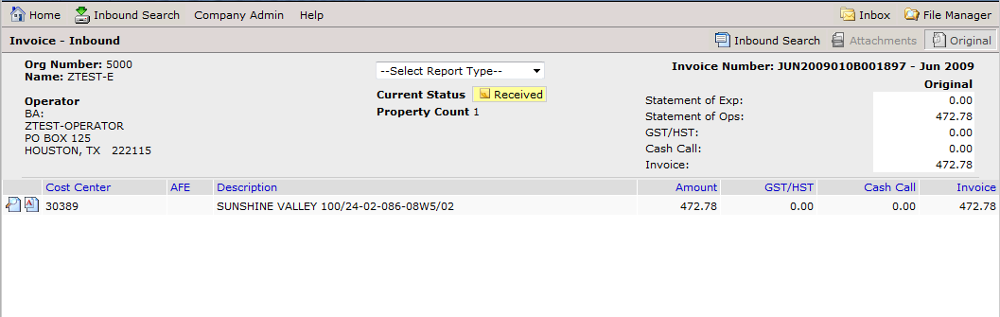

*Click on* the Details icon (magnifying glass icon[ViewFile](https://demo.jiblink.com/XBound/Statement.aspx?Context=Inbound&InvoiceType=INV&InvoiceLineID=92594693&InvoiceNumber=JUN2009010B001897&BatchID=46467&View=Original&LoadInvoiceSearch=True) ) on the far left hand side of the property “Description” line to view the details of the property.

*Click on* the Comments icon (the letter “A” icon[i_comments](https://demo.jiblink.com/Correspondence/Inbox.aspx?Context=Inbound&SearchStartDate=01/31/2011&id=46467&invl=92594693&MasterCCID=982029&MasterAFEID=-1&SearchInvoice=JUN2009010B001897&Back=Invoice&s=) ) to view additional information from the Operator. If there is additional information, the comments icon will be highlighted in orange; and if there are no comments, then it will be highlighted in white.



Icons for “Details” and “Comments”

### Viewing Attachments via Email Notification

*Click on* the hyperlink text “View Attachments” in the email to view attached documents (such as excel spreadsheets) provided by the Operator. Clicking on “View Attachments” will launch the JIBLink website. Once the JIBLink Login page is displayed on your screen, simply *type in* your Password in the box (the User ID for your account will appear automatically in the User ID box as it is pre-populated) and *click on* the “Login” button.

Once you have successfully logged in, you will be taken to the Attachments screen. *Click on* the filename hyperlink to view the attachment:

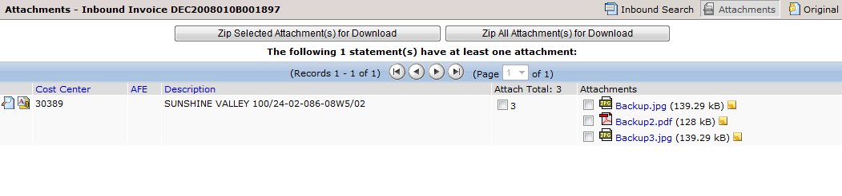

Click to view attachment

Should you wish to save electronic copies of the attachments to a zip file, *check* the boxes beside the attachments to be included in the zip file and c*lick* the “Zip Selected Attachment(s) for Download” button to create a zipped file for the selected items.

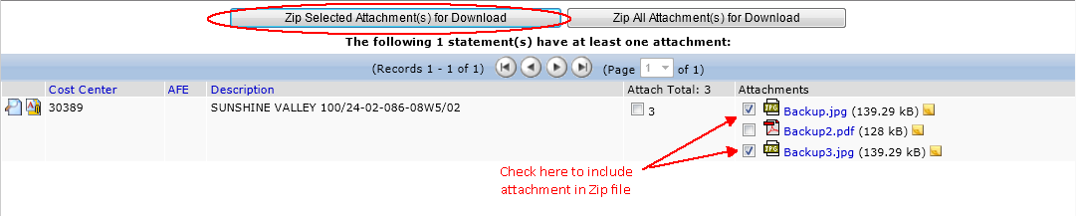

To include all attachments, simply click the “Zip All Attachment(s) for Download” button.

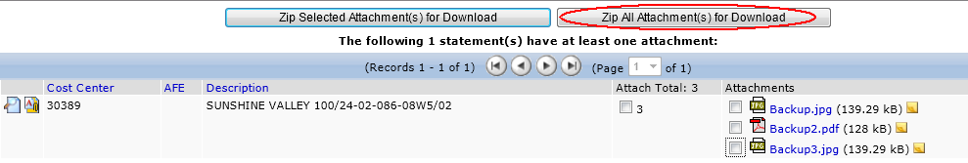

### Printing an Invoice/Statement via Email Notification

*Click on* the hyperlink text “Print Invoice” in the email to display the invoice/statement as a document in PDF format. *Clicking* on “Print Invoice” will launch the JIBLink website. Once the JIBLink Login page is displayed on your screen, simply *type* in your Password in the box (the User ID for your account will appear automatically in the User ID box as it is pre-populated) and *click on* the “Login” button.

Once you have successfully logged in, the PDF document will be displayed on your screen. The PDF document displayed can be printed as long as your computer is connected to an active printer.

*Click on* the printer icon, on the top ribbon of the screen displaying the PDF document, to produce a paper copy of the Operator’s invoice/statement from your printer.

Example PDF document

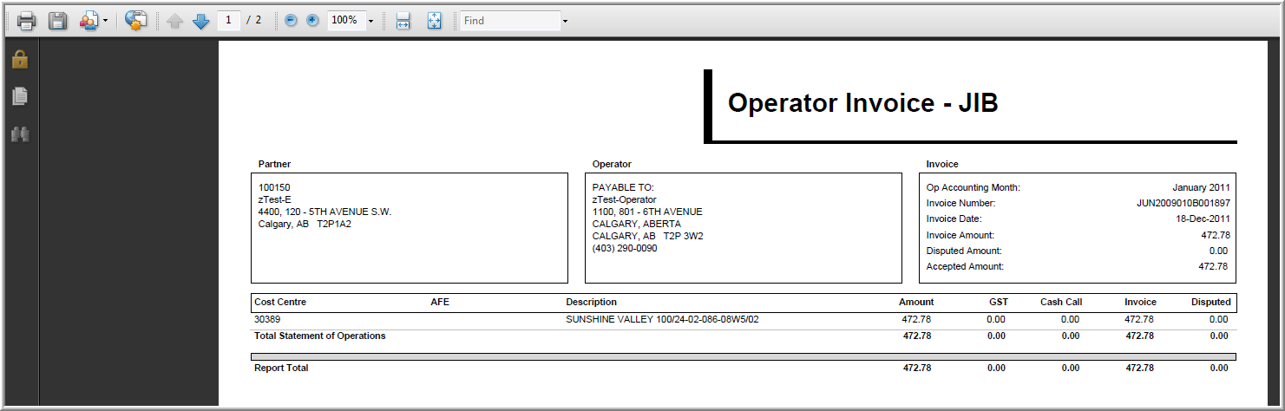

Printer icon

# Managing your Invoices/Statements using JIBLink

The built-in functionality of JIBLink allows Partners/Owners to do far more than simply view and print invoices: this section describes how to navigate the JIBLink website to do things such as search, sort and review the status of invoices/statements; cancel an invoice/statement; access contact information for the Operator; print copies; and view comments and attachments.

## Navigating the JIBLink “Inbound – Invoice Search” screen

Once you have successfully logged in to the JIBLink website using your User ID and Password, a screen called “Inbound - Invoice Search” will be displayed.

### Search Fields

You can search through the invoice/statement history in JIBLink on the “Inbound – Invoice Search” screen using a variety of search criteria including Action Items Only; Date; Operator’s Company Name; Invoice / Pmt #; and Invoice Type.

Example ‘Inbound-Invoice Search’ screen

Editable Search Field criteria



Icons

**Search field criteria definitions:**

* Action Items Only: *Put a checkmark in the small box* next to “Action Items Only” to display only invoices/statements that have not been cancelled. Remove the checkmark to display all invoices/statements sent by the Operator (including cancelled invoices/statements).
* Date Range: S*elect* “From” and “To” month and year by using down arrows beside each selection box.
* Name: *Type any part of an Operator’s name* in this box to view all invoices/statements from that Operator only.
* Invoice / Pmt #: *Type any part of an invoice number or cheque/EFT number* in this box to view a specific invoice/statement or payment number.
* Invoice Type: *Select an invoice type* by using the down arrows beside the selection box. “Invoice Type” includes (JIB, Land, Landmin, Landsur, and Royalty).

**Note:** *Click the “*Search” *button* to perform the search or *click* “Reset” to reset the search criteria to the default settings.

**Icons on screen and their associated actions:**

[Description: Description: https://www.jiblink.com/Images/Icons/ViewFile.gif](https://www.jiblink.com/Xbound/Invoice.aspx?BatchID=72050&InvoiceNumber=233323201110&InvoiceType=INV&Context=Inbound&View=Original&Reload=True) “Details”, symbolized by the magnifying glass icon**:** *Click on* it to view the details of the invoice/statement (list of properties and dollar amounts).

[Description: Description: https://www.jiblink.com/Images/Icons/DeleteFile.gif](javascript:__doPostBack('ctl00$cphGrid$InvoicesGrid$ctl02$CancelInvoice','')) “Cancel”, symbolized by the red circle with the white X icon: *Click on* it to remove an invoice/ statement from the “Action Items Only” list. A cancelled invoice/statement can be viewed by removing the check mark from the “Action Items Only” check box under the search criteria fields.

i_comments “Comments”, symbolized by the letter “A” icon: *Click on* it to view your Operators’ comments on a particular invoice/statement. If the Operator has provided a comment, the “A” icon will be highlighted in orange; and if there are no comments, then it will be highlighted in white i_comments .

[Description: Description: https://www.jiblink.com/Images/Icons/PrintFile.gif](https://www.jiblink.com/XBound/PrintInvoice.aspx?BatchID=72050&InvoiceNumber=233323201110&InvoiceType=0) “Print”, symbolized by the Printer icon: *Click on* it to generate a PDF document of the entire invoice/statement package.

### Page Numbers for Multiple Records

Each invoice/statement is referenced as a ‘record’. JIBLink will list 25 invoice/statement records per page. If there are more than can be shown on one page, then additional screen pages are required to list all of the records. To see all of the records, move from page-to-page by *clicking* on the navigation arrows or using the drop down box and *selecting* the desired page number from the page number options.

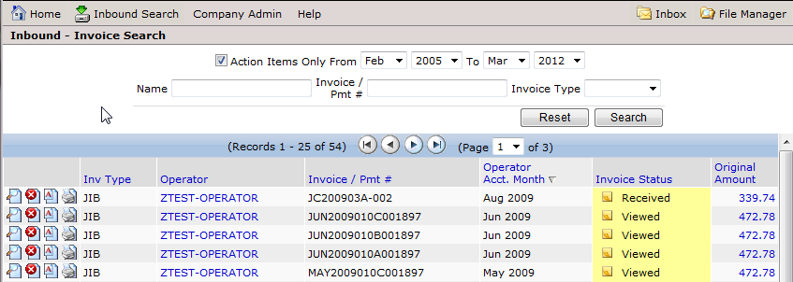

In the record count, “Records 1 - 25 of 54”, the last number signifies the total number of invoice/statement records resulting from the search; in this case, 54 records across 3 pages.

### Sorting Invoices/Statements

The column titles, text in the blue colored font, on the “Inbound - Invoice Search” screen are hyperlinks that can be used to sort the data in the columns.





*Click on* the blue hyperlink at the top of a column to sort the data in that column. *Click once* to sort data in ascending order and *click* twice to sort in descending order.

For example, clicking on “Inv Type” will sort the list of invoice/statement records based on the type of invoice/statement records in the search results.

The data associated within each of the hyperlink column titles is defined as:

* Inv Type: Invoice type being receive: JIB, Landmin, Landsur, Royalty
* Operator: Company sending you the information
* Invoice / Pmt#: Invoice/statement number; and cheque/EFT number
* Operator Acct. Month: Operator’s accounting month
* Invoice Status: Current status of that invoice/statement
* Original Amount: Total amount for that invoice/statement

### Invoice Status Column

This column on the screen contains information regarding the current staus of the invoices/ statements sent to you by your Operators.

**Status definitions:**

* Received: The invoice/statement has been received, but not viewed
* Viewed: The invoice/statement has been viewed or printed
* Cancelled: The invoice/statement has been cancelled which removes it from the “Action Items Only” list
* Cancel Removed: The invoice/statement has had the cancel removed, placing it back in the “Action Items Only” list

## Cancelling; and Removing the Cancel Status on an Invoice/Statement

Cancelling an invoice/statement removes it from the “Action Items Only” list on the “Inbound – Invoice Search” screen. Users cancel invoices/statements in order to identify which ones have been dealt with and which ones still require action. The following are some reasons for cancelling an invoice/statement:

* The invoice/statement has been paid
* The Royalty cheque has been received
* You have printed a copy of the invoice/statement

To cancel an invoice/statement, *click on* the Cancel Invoice icon[DeleteFile](javascript:__doPostBack('ctl00$cphGrid$InvoicesGrid$ctl02$CancelInvoice','')). A green message bar will appear on the screen to confirm that the invoice/statement was cancelled and the invoice/statement will be removed from the action items list.

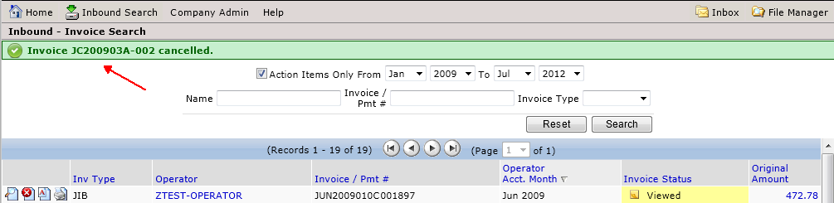

If you’ve cancelled an invoice/statement by mistake, you can remove the cancelled status by *Clicking* inside the box beside “Actions Items Only” to remove the check mark from inside the box. Once the box is empty, i.e. no check mark, then *click on* the “Search” button. Locate the invoice/statement that was cancelled in error and *click on* the remove cancel icon “ ”.

A green message bar will appear on the screen to confirm that the cancel was removed from the invoice/statement and the “InvoiceStatus” should now be changed to “Cancel Removed”.

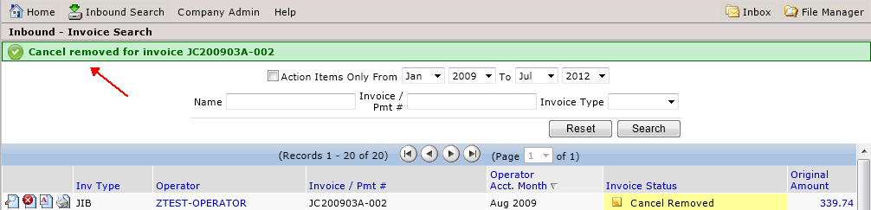

## How to Contact Your Operator

While working in JIBLink as a Partner/Owner, it is easy to find your contact for a particular Operator. If you have questions regarding direct deposits, account changes, bank account changes, incorrect information or late invoices/statements, and wish to contact the Operator, then all of their contact information is accessible through an active hyperlink in the “Operator” column.

*Click directly on* the Operator’s name listed in the column and the hyperlink will open up a new window with the Operator’s contact information.

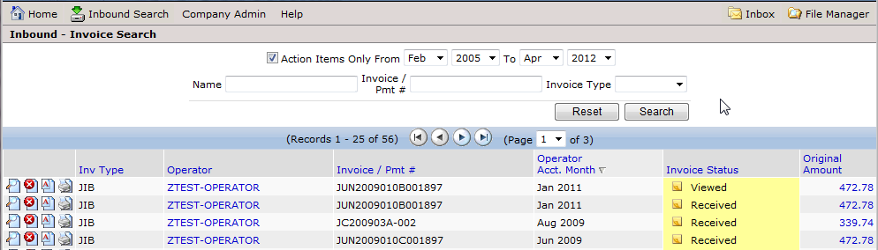

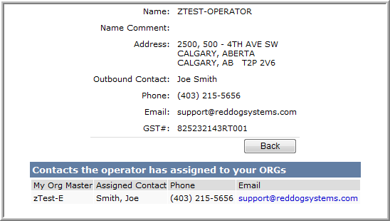

*Click* on the Operator’s name to open the contact information screen.

Contact information screen

The new screen provides you with contact information for the person at the Operator’s company who is handling your account.

## Print Sections of an Operator Invoice/Statement

*Log directly into the website* at [www.JIBLink.com](http://www.JIBLink.com) as described in section 1.1, this will take you to the “Inbound – Invoice Search” screen. From there, follow the steps outlined in this section to print sections of an Operator invoice/statement.

From the “Inbound – Invoice Search” screen, *click* *on* “Details”, the “[ViewFile](https://test.jiblink.com/Xbound/Invoice.aspx?BatchID=44736&InvoiceNumber=JC200903A-002&InvoiceType=INV&Context=Inbound&View=Original&Reload=True)” icon beside the invoice/statement you wish to view/print. See the example below:

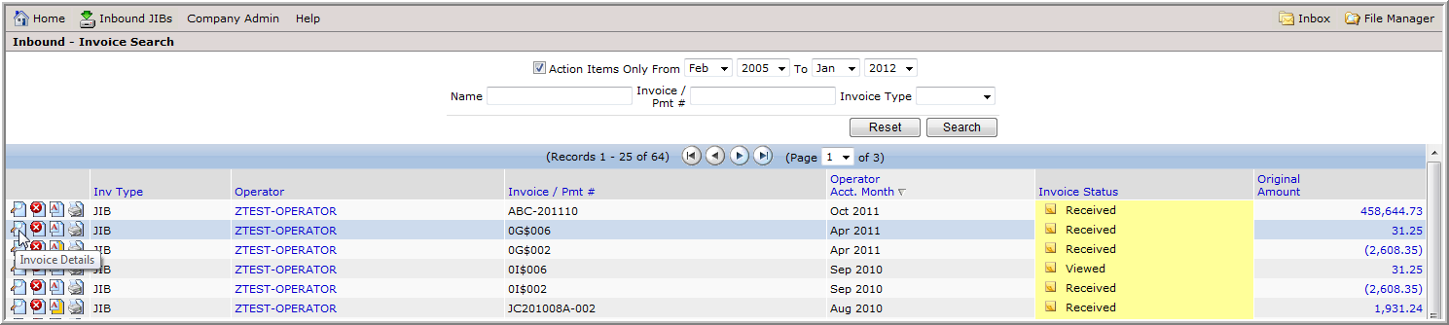

To display a list of print options, *click the down arrow beside* “Select Report Type”.

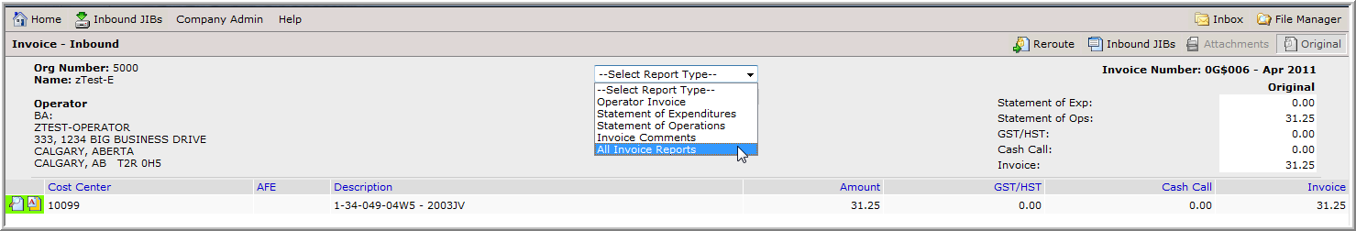

Print options

There are 5 reports to choose from defined as follows:

* Operator Invoice: invoice/statement summary only
* Statement of Expenditures: capital statements only
* Statement of Operations: revenue and expense statements only
* Invoice Comments: invoice comments only
* All Invoice Reports: entire invoice package containing all reports

*Select* the report you wish to print and *click* the printer icon to queue your report to JIBLink’s “File Manager”.

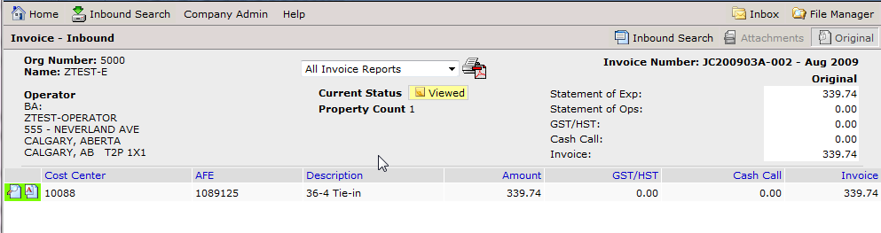

*Click* the“File Manager” button, circled inred on the above sample screen.

A small window will open; *click on the green area*, where it says “Click to View”.

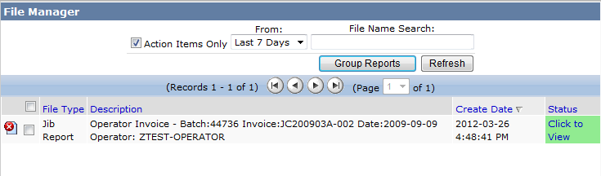

Click here to retrieve the file

To be able to print the file, *click on the* OPEN *button*; or c*lick* *on the* SAVE *button* to save the information to a file on your personal computer or network.

## Invoice and Property Comments

Operators have the ability to add invoice comments and property comments to your invoices/statements. These comments are used to provide you with additional information regarding their invoices/statements.

If the Operator has added comments to your invoice/statements, the Comments icon (the letter “A” icon[i_comments](https://demo.jiblink.com/Correspondence/Inbox.aspx?Context=Inbound&SearchStartDate=01/31/2011&id=46467&invl=92594693&MasterCCID=982029&MasterAFEID=-1&SearchInvoice=JUN2009010B001897&Back=Invoice&s=) ) will be highlighted in orange; and if there are no comments, it will be highlighted in white[i_comments](https://demo.jiblink.com/Correspondence/Inbox.aspx?Context=Inbound&SearchStartDate=01/31/2011&id=46467&invl=92594693&MasterCCID=982029&MasterAFEID=-1&SearchInvoice=JUN2009010B001897&Back=Invoice&s=).

### Viewing Invoice Comments

From the “Inbound – Invoice Search” screen, *click* *on* “Invoice Comments”, the “” icon beside the invoice/statement you wish to view the comment for. See the example below:

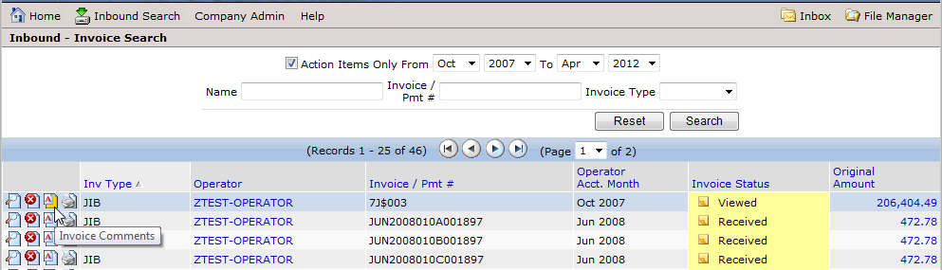

**Note:** Comments from the Operator will be shown on the invoice/statement once printed.

A new window will open; *click* *the appropriate row* to read the message, which will display on the lower half of the screen.

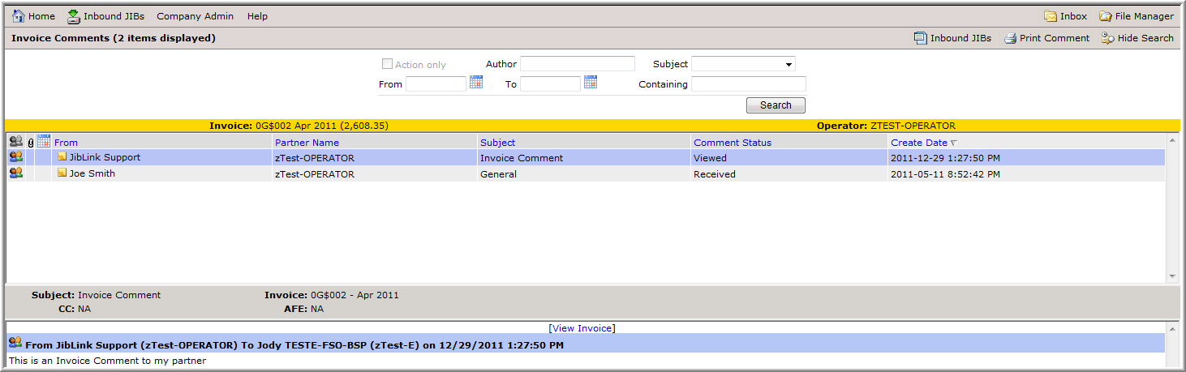

Message from your Operator

### Viewing Property Comments and Attachment(s)

From the “Invoice – Inbound” screen, *click* *on* the “[i_comments_attach_other](https://www.jiblink.com/Correspondence/Inbox.aspx?Context=Inbound&SearchStartDate=04/30/2011&id=64885&invl=154292848&MasterCCID=1239472&MasterAFEID=-1&SearchInvoice=0G$002&Back=Invoice&s=)” icon beside the property you wish to view the comment for. See the example below:

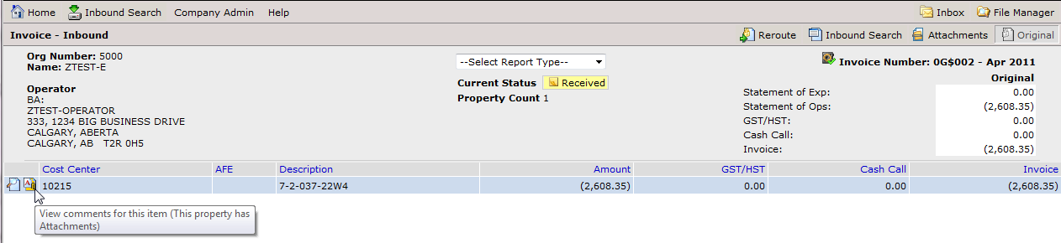

A new window will open; *click* *the appropriate row* to read the message and view the attachment(s), which will display on the lower half of the screen.

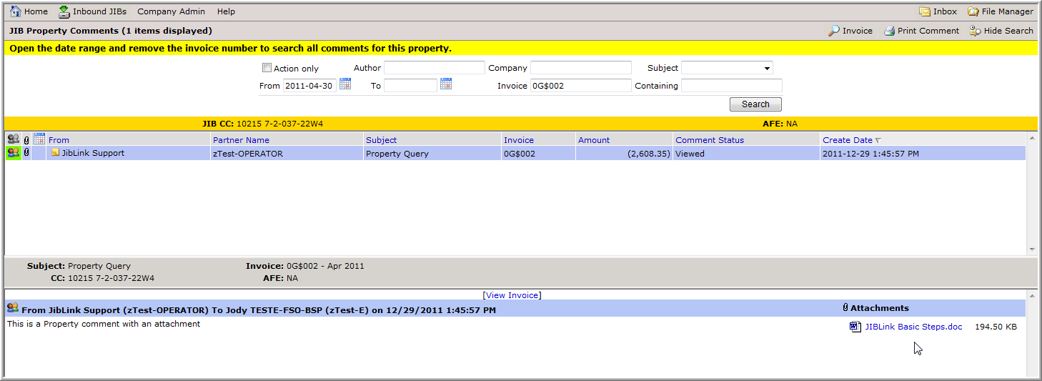

*Click* on the attachment to view or save the file.

To go back to your Invoice, *click on* “i_viewInvoice” (top right) or on the hyperlink “View Invoice”**.**  


# Updating Company & User Information

## Updating Company Address and Contacts

*Hover* your mouse on the “Company Admin” menu and *click* *on* “ORG Master”.

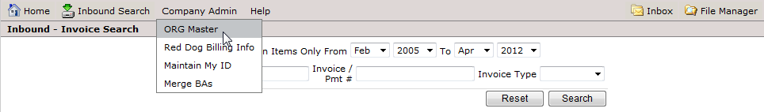

*Click* *on* “View Master Details”, the “[View Master Details](https://www.jiblink.com/MasterOrg/MasterOrgDetail.aspx?MasterOrgId=4586)” icon beside the organization you wish to update.

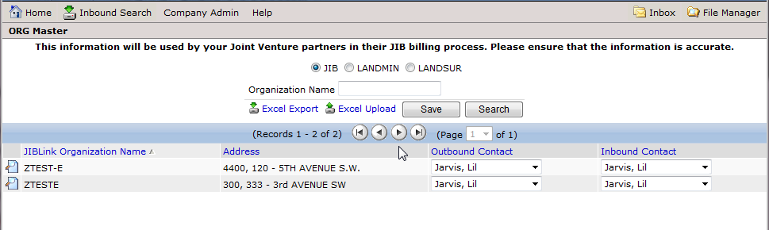

A new window will open; *edit* *your company and contact information* and *click* “Save”.

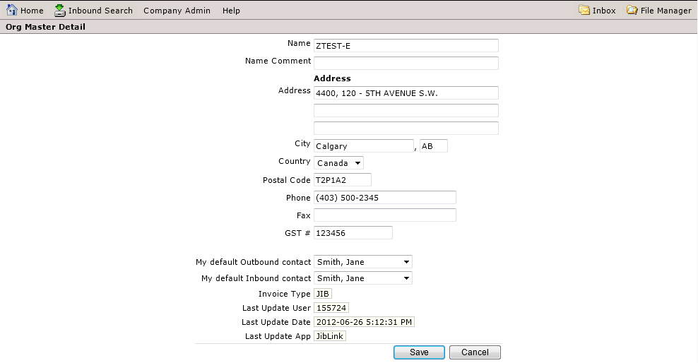

“My default Inbound contact” represents the user that will receive email notifications when an operator releases their invoices/statements.

**Note**: JIBLink organizations are independent across invoice types. Updates to an organization under **JIB** will not apply to the same organization under **LANDMIN, LANDSUR or ROYALTY.**



If applicable, change address and contact information for all types of invoice/statements **(JIB, LANDMIN, LANDSUR & ROYALTY)**. Simply *click* *on* the toggles for each type, to view other orgs that require updates.

## Updating your User Information and Password

*Hover* your mouse on the “Company Admin” menu and *click* on “Maintain My ID”.

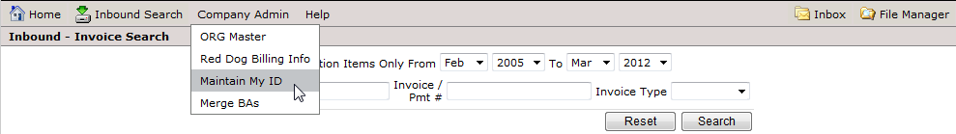

A new window will open; you can *edit* your user information such as your first name, last name, title, phone number, email address and password.

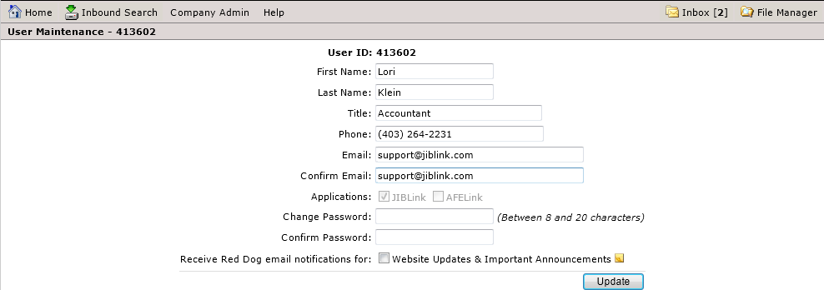

To receive updates and important website announcement notifications, select the “Website Updates & Important Announcements” checkbox.



*Click* “Update” when you are finished making your changes.

Password criteria are as follows:

* Password must be between 8 and 20 characters
* Password cannot contain your User ID
* Password must contain an alphabetic character, plus either a numeric or special character
* Passwords are case sensitive